(Approx. 830 words)

Kretchmar’s Korner
The Simple Game of Solitaire?
By David Kretchmar, Computer Hardware technician,
Sun City Summerlin Computer Club, NV
March 2018 issue, Gigabyte Gazette
www.scscc.club
tomburt89134 (at) cox.net

I admit it: I play Microsoft Solitaire (my game: Klondike Solitaire: draw 1, with 3 times through the deck, Vegas scoring). Of course, it's the most widely-played computer game of all time. Sometimes I play for an hour or more at a time, usually while watching TV.

I play “thoughtful solitaire” and will replay a game many times until I beat it, or I determine it cannot be beat (with the effort I want to put into it). More on that later.
Klondike Solitaire has become a universal computer program or application, used by over a half-billion users worldwide, on all major operating systems. I’m going to be specifically discussing the Klondike Solitaire game included with the Windows 10 operating system. This is essentially the same game that has been included in all modern versions of Windows.

Solitaire has long been a popular waste-of-time, and the computer version of the game has made it even more popular. With a little effort and repetition, a player can gain a good working knowledge of the position of each pertinent card in the deck and ultimately know that they have played the best possible game with each set of 52 cards. Remember one thing when playing Solitaire on a computer; if you can do it, it’s not cheating.

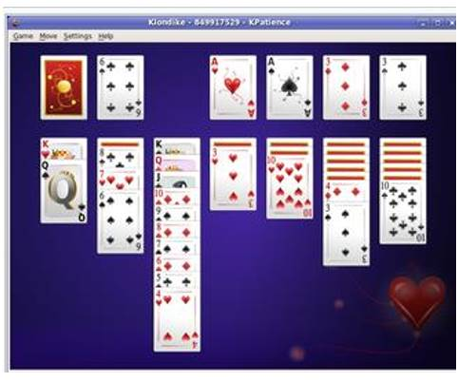

Klondike Solitaire is played with a 52-card standard deck, with the layout as shown on the left. There are two main variations of the game; (1) turning over every 3 cards with no limit on the number of passes through the deck and (2) turning over each card, going through the deck 3 times.

A very big number of possible hands
When I started investigating the odds of winning a game of Solitaire (moving all the cards to the Ace piles) I was amazed at the total number of different outcomes possible. I won’t get into the details of the mind-boggling math involved, but there are 8 times 10 to the 67th power (8 with 67 zeros after it) different ways of shuffling 52 cards. This number is obviously massive – certainly beyond the understanding of humans and so large it is impossible for today’s most powerful computers to accurately compute the odds of winning a game.

Due to the limitation of computers, an exact mathematical solution to the question of what percentage of games are winnable does not exist and, because of the massive number of possibilities, statistical solutions based on playing a huge number of games are wildly inaccurate. Theoreticians have struggled with this game, referring to the inability to calculate the odds of winning a randomly dealt game as “one of the embarrassments of applied mathematics”

Monte Carlo Simulation – 79 to 92 percent of Solitaire games are winnable!
Enter the Monte Carlo Simulation. The Monte Carlo method was invented by scientists working on the atomic bomb in the 1940s, who named it for the city in Monaco famed for its games of chance. Its core idea is to use random samples of parameters or inputs to explore the behavior of a complex system or process that is too complex to be computed (like Solitaire).

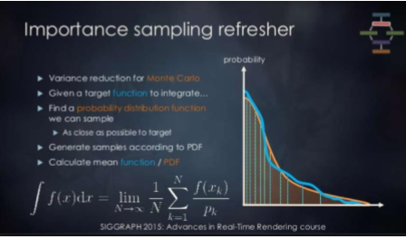
Using Monte Carlo simulation for many millions of hands of Solitaire – this is really brute force – estimates of the percentage of winnable Solitaire games, for draw 3, are believed to be between 79% and 92%. I have not come across an analysis, but I know the draw 1 Solitaire game is somewhat easier to win than the draw 3 game, since the player is going to see every single card in the draw pile at least 3 times. I would guess the probability of winning a draw 1 game is at least 92%, possibly much higher. Yet even excellent Solitaire players win fewer than 10% of games played, at least on their first try.

Human error and what turn out to be non-optimal decisions account for the difference between potential wins and actual winning hands. For example: during games a player will have a choice of which card to play; playing a ten of hearts on a black jack instead of a ten of diamonds can result in an entirely different game outcome. A player can only guess which play is optimal, and sometimes the ultimate result of a decision tree will not be known until the end of the game.

Thoughtful Solitaire
Solitaire does not have to be a mind-numbing exercise, if you approach each game as probably winnable. If on your first try you lose, play that game again making different decisions as you reach each decision tree. Winning a game of Solitaire, you have lost, sometimes lost several times, is immensely satisfying. Thoughtful Solitaire players will win many times more games than the typical “one and done” player and, in the process, they exercise and stimulate their brains.

